VOICE CONTROLLED VIRTUAL ASSISTANT
Project Synopsis

Agile Development Methodologies (IBD413)
Degree
BACHELOR OF TECHNOLOGY (IBM)

PROJECT GUIDE:  Mr. Pritam Mohanta | SUBMITTED BY:  Mann Garg (TCA2457011)  Hamza Beg (TCA2457012)  Palak Chauhan (TCA2457015)  Samriddhi Goyal (TCA2457020)

January-June, 2026



COLLEGE OF COMPUTING SCIENCES & INFORMATION TECHNOLOGY
TEERTHANKER MAHAVEER UNIVERSITY, MORADABAD
Table of Contents

1 Project Title 3
2 Domain 3
3 Problem Statement 3
4 Project Description 3
4.1 Scope of the Work 3
4.2 Project Modules 4
5 Implementation Methodology 4
6 Technologies to be used 5
6.1 Software Platform 5
6.2 Hardware Platform 5
6.3 Tools 5
7 Advantages of this Project 6
8 Future Scope and further enhancement of the Project 6
9 Team Details 6
10 Conclusion 7
11 References 7

Project Title
Voice Controlled Virtual Assistant

Domain
The proposed project belongs to the domain of Artificial Intelligence and Human-Computer Interaction, with implementation using Python-based automation technologies.

Problem Statement
In the modern digital environment, traditional input methods such as keyboards and mice are widely used for interacting with computer systems. However, these methods can be time-consuming and inconvenient, especially in situations where hands-free operation is required. Users with physical limitations or those engaged in multitasking often face difficulties using conventional input devices.
To address these challenges, there is a growing need for an intuitive and efficient interaction system. A voice-controlled virtual assistant provides a solution by enabling users to interact with computers through natural speech, thereby improving accessibility, efficiency, and user experience.

Project Description
The Voice Controlled Virtual Assistant is a software application designed to perform tasks based on voice commands provided by the user. The system utilizes speech recognition technology to convert spoken language into text, processes the command, and executes the corresponding action.
The application is capable of performing various operations such as opening applications, searching information on the internet, retrieving data from Wikipedia, and providing real-time responses like current time. Additionally, a graphical user interface (GUI) enhances usability and interaction.

Scope of the Work
The scope of this project includes the development of a basic voice assistant capable of recognizing user commands, processing them, and executing predefined tasks. The system focuses on desktop-based automation and includes features such as voice recognition, command execution, and voice feedback.
However, the project does not cover advanced artificial intelligence capabilities such as deep learning-based conversation, emotion detection, or fully offline processing with high accuracy.

Project Modules
The system is divided into the following modules:
- Speech Recognition Module: Captures user voice input and converts it into text.
- Command Processing Module: Interprets the text and identifies the intended command.
- Execution Module: Performs the requested task, such as opening applications or searching the web.
- Voice Response Module: Provides output in the form of synthesized speech.
- Graphical User Interface Module: Facilitates user interaction through a visual interface.
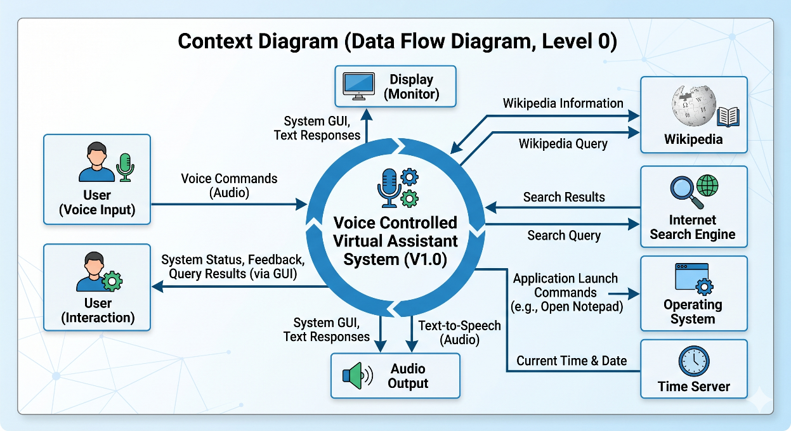

Implementation Methodology
The development of the system follows a structured approach involving multiple stages. Initially, the system captures voice input using a microphone. This input is processed using a speech recognition library to convert it into textual data. The text is then analyzed to determine the user’s intent.
Based on the identified command, the system executes the appropriate function, such as launching an application, performing a web search, or retrieving information. The output is then delivered to the user in both text and voice formats.
The system architecture follows a sequential flow:
User Input → Speech Recognition → Command Processing → Execution → Output
Testing of the system is conducted by validating different voice commands under various conditions to ensure accuracy and reliability.
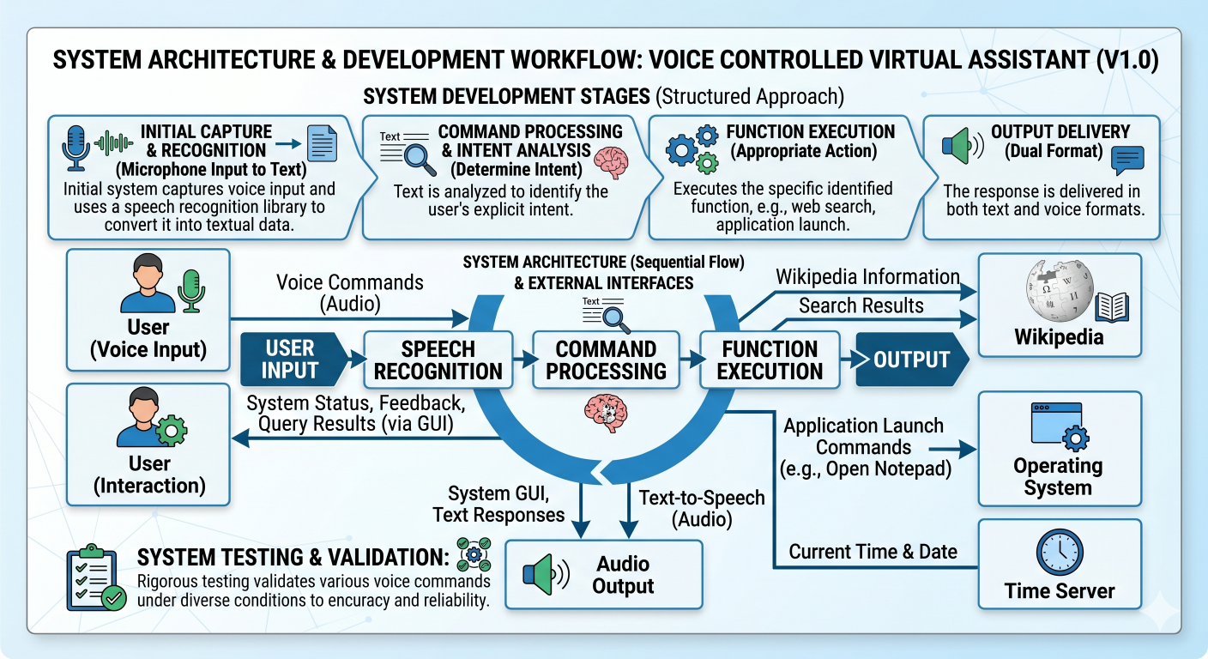

Technologies to be used

Software Platform
- Front-end
Tkinter (for GUI development)

- Back-end
Python

Hardware Platform
- Computer/Laptop with minimum 4GB RAM
- Microphone for voice input
- Operating System: Windows

Tools
- Python IDE (VS Code / PyCharm)
- SpeechRecognition Library
- pyttsx3 (Text-to-Speech)
- Wikipedia API
- Webbrowser Module
- OS Module

Advantages of this Project
The proposed system offers several advantages:
- Provides hands-free interaction with the computer
- Enhances accessibility for users with physical limitations
- Saves time by automating routine tasks
- Offers a simple and user-friendly interface
- Improves efficiency in executing commands

Future Scope and further enhancement of the Project
The project can be further enhanced by integrating advanced technologies and expanding its capabilities. Future improvements may include:
- Integration of artificial intelligence for smarter responses
- Development of a mobile application version
- Implementation of smart home automation features
- Addition of multi-language support
- Improved noise handling and offline functionality

Team Details

Project Name & ID | Course Name | Student ID | Student Name | Role | Signature
Voice Controlled Virtual Assistant | Bachelor of Technology (IBM) | TCA2457011 | Mann Garg | Developer
 |  | TCA2457012 | Hamza Beg | Tester
 |  | TCA2457015 | Palak Chauhan | Designer
 |  | TCA2457020 | Samriddhi Goyal | Documentation

Conclusion
The Voice Controlled Virtual Assistant project demonstrates the practical implementation of voice recognition technology for automating computer-based tasks. The system successfully enables users to interact with machines using natural language, thereby improving usability and efficiency.
Although the current implementation is limited to basic functionalities, it provides a strong foundation for future enhancements involving artificial intelligence and advanced automation. The project highlights the potential of voice-based systems in shaping the future of human-computer interaction.

References
- Python Official Documentation
- SpeechRecognition Library Documentation
- pyttsx3 Documentation
- Wikipedia API Documentation
- Various online tutorials and learning resources

